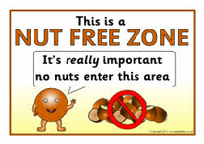
June 2020

Dear Parents
We are a “nut free” school because we have children at All Saints who are allergic to NUTS which can be a life threatening condition. Please can you help us to protect these children by being vigilant when bringing any foods into the school such as snacks for break time and lunchtime.

It is becoming increasingly difficult when children bring in cakes or sweets to hand out to their classmates on their birthdays as many of these food items are labelled “may contain nuts”. We have to then ask parents to take the treats home again and children are disappointed that they cannot share them with their friends.
Please DO NOT send in any treats such as cakes or sweets for your children’s birthdays or celebrations. We respectfully ask that treats are not handed out on the school playground.
Thank-you.
I would be grateful if you could sign and return the slip at the end of this letter to let me know that you have received and read this letter.
I thank you in advance for your understanding and cooperation.
Yours sincerely

Rachael Hutchinson
Head Teacher

…………………………………………………………………………………………………………………………………………………………….Nut Free Zone
I confirm I have received the Nut Free Zone letter and I agree not to send snacks, packed lunches, birthday treats or any other food into school which contain nuts.
Childs name…………………………………………………………Class…………………..
Signed………………………………………………………………… Parent/guardian

